

B. Tech. (Computer Science and Engineering)
A22 Regulation

MACHINE LEARNING

LAB MANUAL

Subject Code: Code: 9EC65
Regulations: A22 JNTUH
Class: III Year B.Tech .II Semester

MACHINE LEARNING LAB

Course Objective: The objective of this lab is to get an overview of the various machine learning techniques and can able to demonstrate them using python.

Course Outcomes: After the completion of the course the student can able to:
1. Generalize complexity of Machine Learning algorithms in real-world data and their limitations.[L2]

Program Outcomes

 | Program Outcomes
Course outcomes | PO 1 | PO2 | PO3 | PO4 | PO5 | PO6 | PO7 | PO8 | PO9 | PO10 | PO11 | PO12 | PSO1 | PSO2 | PSO3
CO1 | 3 | 3 | 3 | 3 | 3 | 2 | 3 | -- | --- | -- | -- | 3 | 3 | 3 | 2
Average | 3 | 3 | 3 | 3 | 3 | 2 | 3 | -- | -- | -- | -- | 3 | 3 | 3 | 2

PO’s | 1 | 2 | 3 | 4 | 5 | 6 | 7 | 8 | 9 | 10 | 11 | 12
Level | H | H | H | H | H | M | H | -- | -- | --- | -- | H

B. Tech. (INFORMATION TECHNOLOGY)
A22 Regulation

(Applicable for the Batches admitted from 2022 & 2023)



DEPARTMENT OF INFORMATION TECHNOLOGY
SREENIDHI INSTITUTE OF SCIENCE AND TECHNOLOGY
(An Autonomous Institution approved by UGC and affiliated to JNTUH)
Yamnampet, Ghatkesar, Hyderabad - 501 301

2024-2025

DEPARTMENTOFINFORMATION TECHNOLOGY
MACHINELEARNINGLAB LIST OF EXPERIMENTS
S.No. | NameoftheExperiment
1. | The probabilitythat it is Fridayand that a student is absent is 3 %. Since thereare5schooldays inaweek, theprobabilitythat it isFridayis20%. What istheprobabilitythat astudent isabsent giventhattodayisFriday?  ApplyBaye’sruleinpythontogettheresult.(Ans:15%)
2. | Extractthedatafromdatabaseusingpython
3. | Implementk-nearestneighboursclassificationusingpython
4. | Given the following data, which specify classifications for nine ombinations of VAR1 and VAR2 predict a classification for a case where VAR1=0.906 andVAR2=0.606, usingtheresult ofk-meansclusteringwith3 means(i.e.,3 centroids)  VAR1 VAR2 CLASS 1.713 1.586 0  0.180 1.786 1  0.353 1.240 1  0.940 1.566 0  1.486 0.759 1  1.266 1.106 0  1.540 0.419 1  0.459 1.799 1  0.773 0.186 1
5. | Thefollowingtrainingexamplesmapdescriptionsofindividuals onto high, medium and low

credit-worthiness.
mediumskiingdesign single twenties no ->highRiskhigh golf trading marriedfortiesyes ->lowRiskow speedway transport married thirties yes ->medRisk mediumfootball banking single thirties yes ->lowRiskhigh flyingmedia marriedfiftiesyes ->highRiskow football security single twenties no ->medRisk mediumgolf media single thirties yes ->medRisk mediumgolf transport married forties yes ->lowRiskhigh skiingbanking singlethirties yes ->highRiskow golf unemployedmarriedfortiesyes->highRisk
Inputattributesare(fromlefttoright)income,recreation, job,status,age- group, home-owner. Find the unconditional probability of `golf' and the conditional probability of `single' given `medRisk' in the dataset?
6. | Implementlinearregressionusingpython.
7. | ImplementNaïveBayestheoremtoclassifytheEnglishtext
8. | Implementanalgorithmto demonstratethesignificanceofgenetic algorithm
9. | Implement the finite words classification system using Back-propagation algorithm.
10. | Implement Classification on a sample data set using SVM?

DEPARTMENTOFINFORMATION TECHNOLOGY

MACHINE LEARNING LAB
INTRODUCTIONTON to LAB:
Machine Learning is used anywhere from automating mundane tasks to offering intelligent insights, industries in every sector try to benefit from it. You may already be using a device that utilizes it. For example, a wearable fitness tracker likeFitbit, or an intelligent home assistant like Google Home.But there are much more examples of ML in use.

- Prediction:Machine learning can also be used in the prediction systems. Considering the loan example, to computethe probabilityofa fault, thesystemwillneed to classifythe available data in groups.
- Image recognition:Machine learning canbeused for facedetectioninanimageaswell.There isa separate category for each person in a database of several people.
- Speech Recognition:It is the translation of spoken words into the text. It is used in voice searches and more. Voice user interfaces include voice dialing, call routing, and appliance control. It can also be used a simple data entryand the preparation ofstructured documents.
- Medicaldiagnoses:ML istrainedtorecognizecanceroustissues.
- Financialindustry:andtrading:companiesuseMLinfraudinvestigationsandcreditchecks.

TypesofMachineLearning?

Machinelearningcanbeclassifiedinto3typesofalgorithms

- SupervisedLearning
- UnsupervisedLearning
- ReinforcementLearning

OverviewofSupervised LearningAlgorithm

InSupervised learning, anAIsystemispresentedwithdatawhichis labeled, whichmeansthat eachdata tagged with the correct label.

Thegoalisto approximatethe mapping functionsowellthat whenyouhave new input data(x)thatyou can predict the output variables (Y) for that data.

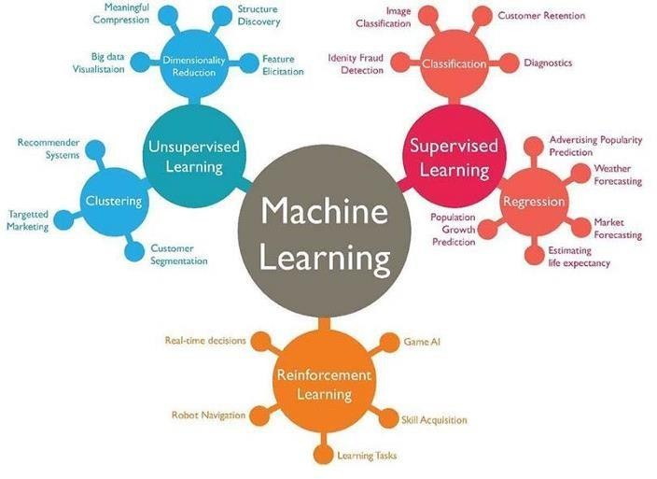

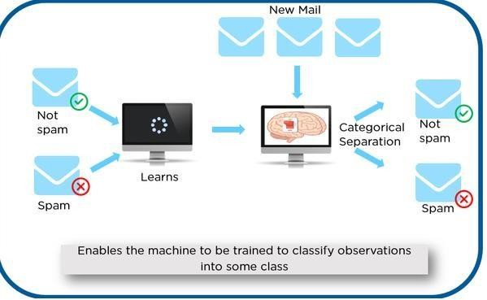

As shown in the above example, we have initially taken some data and marked them as ‘Spam’ or ‘Not Spam’. This labeled data isused bythe training supervised model, thisdata is used to trainthe model.

Onceitis trained we cantest our model bytestingitwithsome testnewmails and checking ofthe model is able to predict the right output.

TypesofSupervised learning
- Classification:Aclassificationproblemiswhentheoutputvariable isacategory, suchas “red”or “blue” or “disease” and “no disease”.
- Regression:Aregressionproblemiswhentheoutput variable isarealvalue, suchas “dollars”or “weight”.

OverviewofUnsupervisedLearningAlgorithm

In unsupervised learning, an AI system is presented with unlabeled, uncategorized data and the system’s algorithms act on the data without prior training. The output is dependent upon the coded algorithms. Subjecting a systemto unsupervised learning is one wayoftesting AI.

TypesofUnsupervisedlearning:
- Clustering: Aclustering problem is where you want to discover the inherent groupings inthe data, such as grouping customers by purchasing behavior.

- Association: Anassociationrule learning problem iswhere you wantto discover rulesthat describe large portions of your data, such as people that buy X also tend to buyY.

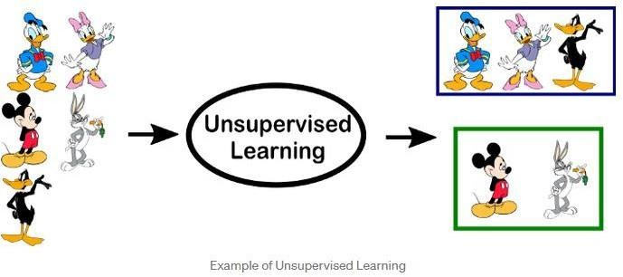

OverviewofReinforcementLearning

A reinforcement learning algorithm, or agent, learns by interacting with its environment. The agent receives rewards by performing correctly and penalties for performing incorrectly. The agent learns without intervention from a human by maximizing its reward and minimizing its penalty. It is a type of dynamic programming that trains algorithms using a systemofreward and punishment.

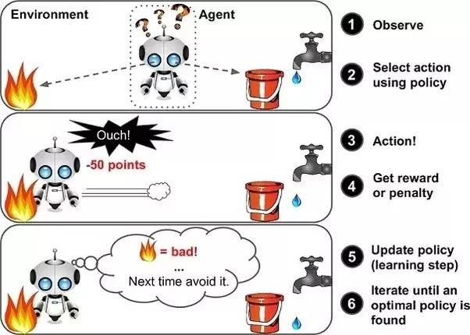

in the aboveexample, wecansee that the agent is given2 options i.e. a pathwithwateror a pathwith fire. A reinforcement algorithm works on reward a system i.e. if the agentuses the fire path then the rewards are subtracted and agent tries to learn that it should avoid the fire path. If it had chosen the water path or the safe path then some points would have been added to the reward points, the agent then would try to learn what path is safe and what path isn’t.

Itisbasicallyleveragingtherewardsobtained;the agent improvesitsenvironment knowledgeto selectthe next action.

PROGRAM1(a)

Write a python program to import and export the data using pandas library

    - Manual Function
Go to Google Page and find www.kaggle.com.Select Datasets and find Titanic dataset, then download train.csv file and save it to desktop.
- Read a CSV file
import pandas as pd url='C:/Users/SNIST/Desktop/train.csv'
dataframe=pd.read_csv(url)dataframe.head(5)

- Write a CSVfile
Import pandas as pd marks_data=pd.DataFrame({'ID':{0:23,1:43,2:12,3:13,4:67,5:89},'NAME':{0:'Ram',1
:'Deep',2:'Yash',3:'Arjun',4:'Aditya',5:'Divya'},'Marks':{0:89,1:92,2:45,3:78,4:56,5:76},'Grade':{0:' b',1:'a',2:'f',3:'c',4:'e',5:'c'}})
filename='C:/Users/SNIST/Desktop/Marksdata.xlsx'marks_data.to_excel(filename)
print('Data frame written to Excel')

- Read an Excel File import pandas as pdurl='C:/Users/SNIST/Desktop/train.csv.xls'dataframe=pd.read_excel(url)dataframe.head(5)
- Write an Excel file
importpandas as pd marks_data=pd.DataFrame({'ID':{0:23,1:43,2:12,3:13,4:67,5:89},'NAME':{0:'Ram',1
:'Deep',2:'Yash',3:'Arjun',4:'Aditya',5:'Divya'},'Marks':{0:89,1:92,2:45,3:78,4:56,5:76},'Grade':{0
:'b',1:'a',2:'f',3:'c',4:'e',5:'c'}})
filename='C:/Users/SNIST/Desktop/Marksdata.csv'marks_data.to_csv(filename)
print('Data frame written to CSV');

Output:
PROGRAM1(b)

The probability thatitisFridayandthatastudentisabsentis3%.Sincethereare5school daysinaweek,theprobabilitythatitisFridayis20%.Whatisthe probabilitythatastudent is absent given that today is Friday? Apply Baye’s rule in python to get the result. (Ans: 15%)

AIM:To find the probability that a student is absent given that today is Friday.

DESCRIPTION:
Machine learning is a method of data analysis that automates analytical model building of data set. Using the implemented algorithms that iteratively learn from data, machinelearning allows computers to find hidden insights without being explicitly programmed where to look. Naivebayes algorithm is one of the most popular machines learning technique. In this article we will look how to implement Naive bayes algorithm using python.
Before someone can understand Bayes’ theorem, they need to know a couple of related concepts first, namely, the idea of Conditional Probability, and Bayes’ Rule.
Conditional Probability is just what is the probabilitythat something will happen, given that something else has already happened.
Let saywe have a collection ofpeople. Some ofthem are singers. They are either male or female. If we select a random sample, whatis the probability that this person is a male? whatis the probability that this person is a male and singer? Conditional Probability is the best option here. We can calculate probability like,
P(Singer &Male)=P(Male)xP(Singer/Male)

WhatisBayesrule ?
We cansimplydefine Bayes rule like this. Let A1, A2, …, Anbe a setofmutuallyexclusive eventsthat together form the sample space S. Let B be any event from the same sample space, such that P(B) > 0. Then,P( Ak | B) =P( Ak ∩ B ) / P( A1 ∩ B ) + P( A2 ∩ B ) +. . . +P( An∩ B )

WhatisBayesclassifier?
Naive Bayes classifiers are a family of simple probabilistic classifiers based on applyingBayes’ theorem with strong (naive) independence assumptions between the features in machine learning. Basically we can use above theories and equations for classification problem.

SOURCE CODE:
. To find the probability that a student is absent given that today is Friday, we use the formula for conditional probability:
P(Absent | Friday)=P(Absent and Friday)​/P(Friday)
From the problem:
P(Absent and Friday)=0.03 (3%)
P(Friday)=0.20 (20%)
P(Absent | Friday)=0.03/0.20​=0.15
So, the probability that a student is absent given that today is Friday is 15%.
The Python code that implements Bayes' Rule to calculate the conditional probability of a student being absent given that today is Friday.
def bayes_rule(p_absent_and_friday, p_friday):
return p_absent_and_friday / p_friday
# Given probabilities
p_absent_and_friday = 0.03 # P(Absent and Friday)
p_friday = 0.20 # P(Friday)
# Calculate P(Absent | Friday)
p_absent_given_friday = bayes_rule(p_absent_and_friday, p_friday)
print("The probability that a student is absent given that today is Friday is:", p_absent_given_friday*100,"%")
Output: The probability that a student is absent given that today is Friday is: 15.0 %

Output:15

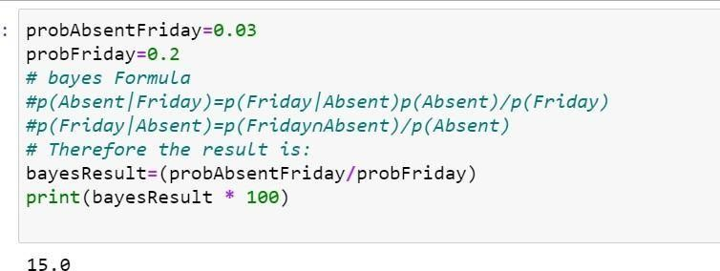

1.5.VIVAQUESTIONS&ANSWERS

WhatareBayesianNetworks(BN)?

Bayesian Network is used to represent the graphical model for probability relationship among a set of variables. Bayes’ theorem is a way to figure out conditional probability. Conditional probability is the probability of an event happening, given that it has some relationship to one or more other events. For example,your probability of getting a parkingspace is connected to the time of day you park, where you park, and what conventions are going onat anytime. Bayes’ theoremis slightlymore nuanced. Ina nutshell, it gives you the actualprobabilityofan event given information about tests.

  - “Events” Are different from “tests.” For example, there is a test for liver disease, but that’s separate from the event of actually having liver disease.
  - Tests are flawed: just because you have a positive test does not mean you actually have the disease. Many tests have a highfalse positive rate. Rare events tend to have higher false positive rates than more common events. We’re not just talking about medical tests here. For example, spam filtering canhave high false positive rates. Bayes’theoremtakesthe test results and calculates your real probability that the test has identified the event.

CanyougiveanyrealtimeexampleusingBayes’Theorem(liverdisease).
You might be interested in finding out a patient’s probability of having liver disease if they are an alcoholic. “Being analcoholic” is the test (kind oflike a litmus test) for liver disease.

  - Acouldmeantheevent“Patienthasliverdisease.”Pastdatatellsyouthat10%ofpatients entering your clinic have liver disease. P(A) = 0.10.
  - B could meanthe litmustestthat “Patient isanalcoholic.” Fivepercent ofthe clinic’spatientsare alcoholics. P(B) = 0.05.
  - You might also knowthat among those patients diagnosed with liver disease, 7% are alcoholics. This is your B|A:the probabilitythat a patient isalcoholic, giventhat theyhave liver disease, is7%.

Bayes’theoremtellsyou:

P(A|B)=(0.07*0.1)/0.05=0.14
Inother words,ifthepatientisanalcoholic,theirchancesofhavingliver diseaseis0.14(14%).

This is a large increase from the 10% suggested by past data. But it’s still unlikely that any particular patient has liver disease.

- Bayes’TheoremExamples2:whatistheprobabilitythattheywillbeprescribedpain pills?
Another way to look at the theorem is to say that one event follows another. Above I said “tests” and “events”, but it’s also legitimate to think of it as the “first event” that leads to the “second event.” There’s no one right wayto do this: use the terminologythat makes most sense to you.
In a particular pain clinic, 10% of patients are prescribed narcotic pain killers. Overall, five percent of the clinic’s patients are addicted to narcotics (including pain killers andillegal substances).Out of all the people prescribed pain pills, 8% are addicts.If a patient is an addict, what is the probability thatthey will be prescribed pain pills?

Step 1:Figure outwhatyourevent“A”is fromthe question. That information is inthe italicized part ofthisparticularquestion. Theeventthat happens first (A)isbeingprescribedpainpills. That’sgivenas 10%.
Step2:Figure outwhatyourevent“B”is fromthe question. That information isalso inthe italicized part ofthis particular question. Event B is being an addict. That’s given as 5%.
Step 3:Figure out what the probability of event B (Step 2) given event A (Step 1). In other words, find what (B|A) is. We want to know“Giventhat people are prescribed painpills, what’sthe probability theyare an addict?” Thatis given in the question as 8%, or .8.

Step4:InsertyouranswersfromSteps1,2and3intotheformulaandsolve. P(A|B) = P(B|A) * P(A) / P(B) = (0.08 * 0.1)/0.05 = 0.16
Theprobabilityofanaddictbeingprescribedpainpillsis0.16(16%).

Bayes’TheoremExamples3:theMedicalTestifa persongetsapositivetestresult.
what are the oddsthey actually havethe geneticdefect?

Aslightlymorecomplicatedexampleinvolvesamedicaltest(inthiscase, agenetictest):

There are severalforms of Bayes’ Theorem out there, and theyare all equivalent (theyare just written in slightly different ways). In this next equation, “X” is used in place of “B.” In addition,you’ll see some changes in the denominator. The proof of why we can rearrange the equation like this is beyond the scope of this article (otherwise it would be 5,000 words instead of 2,000!). However, if you come across a question involving medical tests, you’ll likely be using this alternative formula to find the answer:
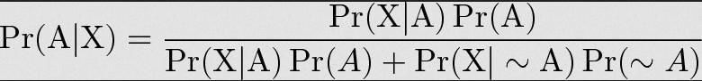

1%ofpeople havea certaingenetic defect.
90%oftestsforthegenedetectthedefect (truepositives). 9.6% of the tests are false positives.
Ifapersongetsapositive testresult,whataretheoddstheyactually havethegeneticdefect?

ThefirststepintosolvingBayes’theoremproblems istoassignletterstoevents:

- A=chanceofhavingthefaultygene. That wasgiveninthequestionas1%. Thatalso meansthe probability of not having the gene (~A) is 99%.
- X=Apositivetestresult.

Sol:

- P(A|X)=Probabilityofhaving thegenegivenapositivetest result.
- P(X|A)=Chanceofapositivetestresult giventhatthepersonactuallyhasthegene. That was given in the question as 90%.
- p(X|~A)=Chanceofapositivetest ifthepersondoesn’thavethegene.That wasgiveninthe question as 9.6%

Nowwehavealloftheinformationweneed to put into theequation:
P(A|X)=(.9*.01)/(.9*.01+.096*.99)=0.0865(8.65%).

The probability of having the faulty gene on the test is 8.65%.

Giventhefollowingstatistics, what istheprobabilitythatawomanhascancerifshehasa positive mammogram result?
  - Onepercentofwomenover50havebreastcancer.
  - Ninetypercentofwomenwhohavebreastcancertestpositiveonmammograms.
  - Eightpercentofwomenwillhavefalsepositives.
Step 1: Assign events to Aor X. You want to know what a woman’s probability of having cancer is, givenapositive mammogram.Forthisproblem, actuallyhavingcancer isAandapositivetestresult is X.
Step2:Listoutthepartsoftheequation(this makes it easier to worktheactualequation): P(A)=0.01
P(~A)=0.99 P(X|A)=0.9 P(X|~A)=0.08
Step3:Insert thepartsintotheequationandsolve. Notethat asthis isa medicaltest,we’reusingthe form of the equation from example #2:
(0.9*0.01)/((0.9*0.01)+(0.08*0.99)= 0.10.

Theprobabilityofawomanhavingcancer,givenapositivetestresult,is10%.

PROGRAM2

EXTRACT THE DATA FROM DATABASE USING PYTHON

You’ll learn the following MySQL SELECT operations from Python using a ‘MySQLConnector Python’ module.

  - ExecutetheSELECTqueryandprocesstheresult setreturned bythequeryinPython.
  - UsePythonvariablesinawhereclauseof aSELECTquery topassdynamic values.
  - Usefetchall(),fetchmany(),andfetchone()methodsofacursorclasstofetchallor limited rows from atable.
  - PythonSelectfromMySQLTable
This article demonstrates how to selectrows of a MySQL table inPython.
You’ll learn the following MySQL SELECT operations from Python using a ‘MySQL Connector Python’ module
.
  - ExecutetheSELECTqueryandprocesstheresultsetreturnedbythequeryinPython.
  - Use Python variables in a where clause ofaSELECTquerytopassdynamicvalues.
  - Use fetchall(),fetchmany(), and fetchone() methods ofa cursor class to fetchallor limited rows fromatable.
  - StepstofetchrowsfromaMySQLdatabasetableFollow thesesteps:–

SOURCE CODE:

Step 1: Create a Table (students) in Mysql Database (SampleDB)
Open Command prompt and then execute the following command to enter into MySQL prompt.
mysql -u root -p
create database SampleDB;
use SampleDB;
CREATE TABLE students (sid VARCHAR(10),sname VARCHAR(10),age int);
INSERT INTO students VALUES('22311A0521','AAA',23);
INSERT INTO students VALUES('22311A0522','BBB',22);
INSERT INTO students VALUES('22311A0523','CCC',25);
INSERT INTO students VALUES('22311A0524','DDD',24);

pip install mysql.connector
# to connect with mysql database through python
import mysql.connector
# Create the connection object
myconn = mysql.connector.connect(host = "localhost", user = "root",passwd = "",database="SampleDB")
# Creating the cursor object
cur = myconn.cursor()
# Executing the query
cur.execute("select * from students")
# Fetching the rows from the cursor object
result = cur.fetchall()
print("Student Details are :")
# Printing the result
for x in result:
print(x);
# Commit the transaction
myconn.commit()
# Close the connection
myconn.close()

OUTPUT:




VIVAQUESTIONSANDANSWERS

Howtoselect froma MySQLtableusingPython?
ConnecttoMySQLfromPython

Referto PythonMySQLdatabaseconnectiontoconnect to MySQLdatabase fromPythonusing MySQL Connector module
Define aSQLSELECTQuery

Next, prepareaSQLSELECT queryto fetchrowsfroma table. You canselect allor limited rowsbased on yourrequirement.If the where conditionisused,thenitdecides the numberof rows tofetch. For example, SELECT col1, col2,…colnN FROM MySQL_table WHEREid = 10;. This will return row number 10.

GetCursor ObjectfromConnection

Next,useaconnection.cursor()methodtocreateacursorobject.ThismethodcreatesanewMySQLCursor
object.

Execute the SELECT query using execute() method Executetheselect queryusingthecursor.execute() method. Extract all rows from a result
AftersuccessfullyexecutingaSelectoperation,Usethe fetchall() methodofacursorobjectto getall rows from a queryresult. it returns a list of rows.
Iterate eachrow

Iterate arowlist usinga for loopandaccesseachrowindividually(Accesseachrow’scolumndata using a column name or index number.)

Closethecursorobjectanddatabaseconnectionobject

usecursor.clsoe()andconnection.clsoe()methodto closeopenconnectionsafteryourworkcompletes.

Whatarethemethodstofetchdatareturned byacursor.execute()

  - cursor.fetchall()tofetchallrows
  - cursor.fetchone()tofetchasinglerow
  - cursor.fetchmany(SIZE)tofetchlimitedrows

PROGRAM3

IMPLEMENT K-NEAREST NEIGHBORS CLASSIFICATION USING PYTHON

AIM:To Implement k-neighbours classification using python

DESCRIPTION:

This algorithm is used tosolve the classification model problems.K-nearestneighbororK-NN algorithm basically creates an imaginary boundary to classify the data.Whennew data points comein, the algorithm will try to predict that to the nearest ofthe boundary line.
Therefore,larger k valuemeans smothercurves of separation resultinginlesscomplexmodels. Whereas, smaller k value tends to over fit the data and resulting in complex models.
It’s very important to have the right k-value when analyzing the dataset to avoid over fitting and under fitting of the dataset.

KNN MODEL REPRESENTATION:
The modelrepresentation for KNN is the entire training dataset.It is as simple as that. KNNhasno modelotherthanstoringtheentiredataset,sothereisnolearningrequired.
Efficient implementations can storethe data using complex data structures like k-d treesto make look-up and matching of new patterns during prediction efficient.
Becausetheentiretrainingdataset isstored, you maywant to thinkcarefullyabouttheconsistencyof your training data. It might be a good idea to curate it, update itoften as new data becomes available and remove erroneous and outlier data.
- Thek-nearest neighboralgorithmisimportedfromthescikit-learnpackage.
- Createfeatureand targetvariables.
- Splitdataintotrainingandtestdata.
- Generateak-NNmodelusingneighborsvalue.
- Trainorfitthedataintothemodel.
- Predictthefuture.

SOURCE CODE:
pip install scikit-learn
Considering Iris Dataset (70% training set and 30% test dataset)
The features of iris dataset sepal length (cm), sepal width (cm), petal length (cm), petal width (cm)

# Import necessary modules
from sklearn.neighbors import KNeighborsClassifier
from sklearn.model_selection import train_test_split
from sklearn.datasets import load_iris
import random

# Loading data
data_iris = load_iris()
# To get list of target names
label_target = data_iris.target_names
print("Sample Data from Iris Dataset")
print("*"*30)
# to display the sample data from the iris dataset
for i in range(10):
rn = random.randint(0,120)
print(data_iris.data[rn],"===>",label_target[data_iris.target[rn]])
# Create feature and target arrays
X = data_iris.data
y = data_iris.target

# Split into training and test set
X_train, X_test, y_train, y_test = train_test_split(
X, y, test_size = 0.3, random_state=1)

print("The Training dataset length: ",len(X_train))
print("The Testing dataset length: ",len(X_test))
try:
nn = int(input("Enter number of neighbors :"))
knn = KNeighborsClassifier(nn)

knn.fit(X_train, y_train)
# to display the score
print("The Score is :",knn.score(X_test, y_test))
# To get test data from the user
test_data = input("Enter Test Data :").split(",")
for i in range(len(test_data)):
test_data[i] = float(test_data[i])
print()
v = knn.predict([test_data])
print("Predicted output is :",label_target[v])
except:
print("Please supply valid input......")
Output:
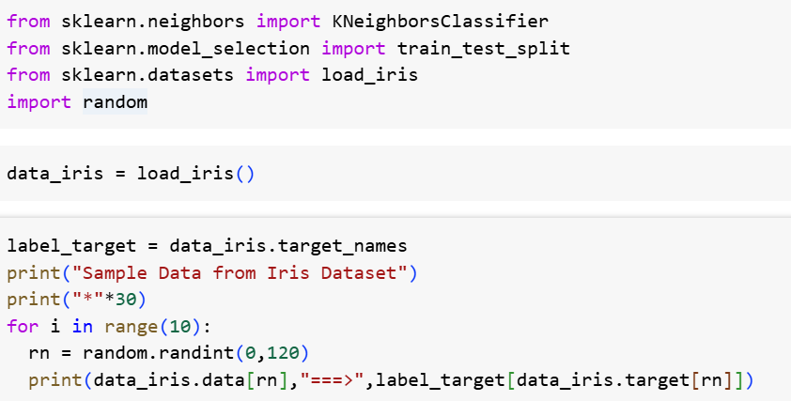
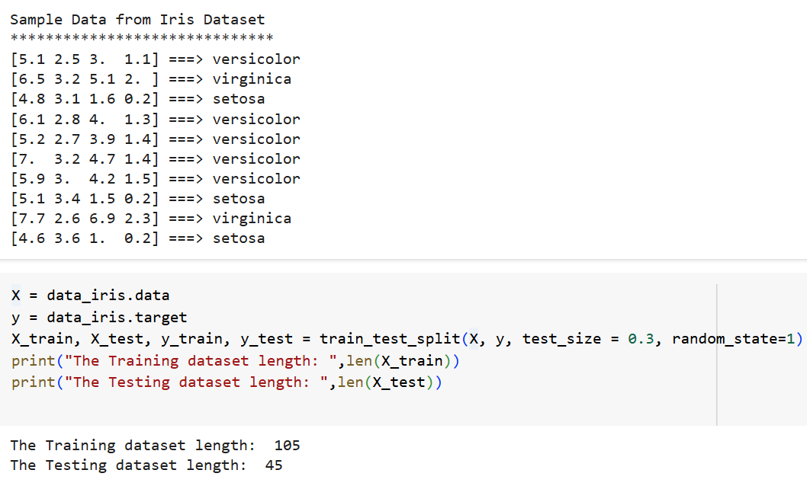
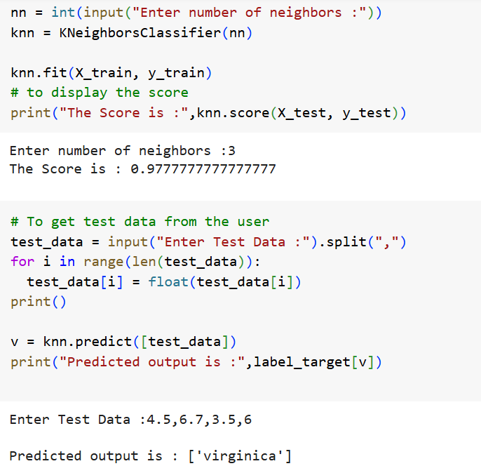
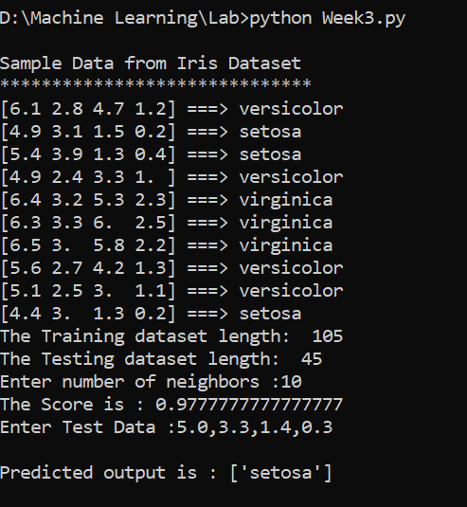

VAQUESTIONS&ANSWERS

WhatistheKNNAlgorithm?

KNN(K-nearestneighbors) isasupervised learningandnon-parametricalgorithmthat canbeusedto solve both classification and regression problem statements.
It uses data in which there is a target column present i.e, labeled data to modela function to produce an outputfortheunseendata. ItusestheEuclideandistance formulato computethedistancebetweenthedata points for classification or prediction.

Themainobjectiveofthisalgorithmisthat similar datapoints must becloseto eachothersoit usesthe distance to calculate the similar points that are close to each other.

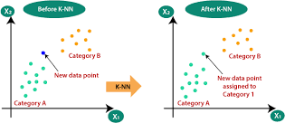

WhyisKNNanon-parametricAlgorithm?
Theterm“non-parametric”refersto notmakinganyassumptionsontheunderlyingdatadistribution. These methods do not have any fixed numbers ofparameters inthe model.

SimilarlyinKNN, the modelparametersgrowwiththetrainingdatabyconsideringeachtrainingcase asa parameter ofthe model. So, KNN is a non-parametric algorithm.

Whatis“K”intheKNNAlgorithm?
Krepresentsthenumberofnearest neighborsyouwant toselectto predicttheclassofagivenitem, which is coming as an unseen dataset for the model.

Whyistheoddvalueof“K”preferred overeven valuesintheKNNAlgorithm?

Theoddvalueof K shouldbepreferredoverevenvaluesin order toensurethatthereareno tiesin the voting. Ifthe square root ofa number ofdata points is even, thenadd or subtract 1to it to make it odd.

HowdoestheKNNalgorithmmakethepredictionsontheunseendataset?

Thefollowingoperations have happenedduringeachiterationofthealgorithm. For eachoftheunseenor test data point, the kNN classifier must:
Step-1:Calculatethe distancesoftestpointtoallpointsinthetrainingsetandstorethem

Step-2: Sort the calculated distances in increasing order Step-3:StoretheKnearest points fromourtrainingdataset Step-4: Calculate the proportions of each class
Step-5:Assigntheclasswiththehighestproportion

PROGRAM-4
- Given thefollowing data, which specify classifications fornine combinations of VAR1 andVAR2predictaclassificationforacasewhereVAR1=0.906andVAR2=0.606,using the result of k-means clustering with 3 means (i.e., 3centroids)
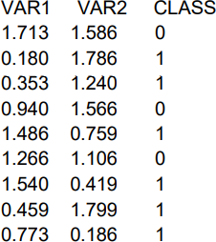

SOURCE CODE:
Sol. We need apply k-means clustering with 3 means (i.e., 3 centroids) and predict the class for the VAR1=0.906 and VAR2=0.606
pip install scikit-learn
from sklearn.cluster import KMeans
import numpy as np
X = np.array([[1.713,1.586], [0.180,1.786], [0.353,1.240],
[0.940,1.566], [1.486,0.759], [1.266,1.106],[1.540,0.419],[0.459,1.799],[0.773,0.186]])
y=np.array([0,1,1,0,1,0,1,1,1])
kmeans = KMeans(n_clusters=3, random_state=0).fit(X,y)
print("The input data is ")
print("VAR1 \t VAR2 \t CLASS")
i=0
for val in X:
print(val[0],"\t",val[1],"\t",y[i])
i+=1
print("="*20)
# To get test data from the user
print("The Test data to predict ")
test_data = []
VAR1 = float(input("Enter Value for VAR1 :"))
VAR2 = float(input("Enter Value for VAR2 :"))
test_data.append(VAR1)
test_data.append(VAR2)
print("="*20)
print("The predicted Class is : ",kmeans.predict([test_data]))

Output:
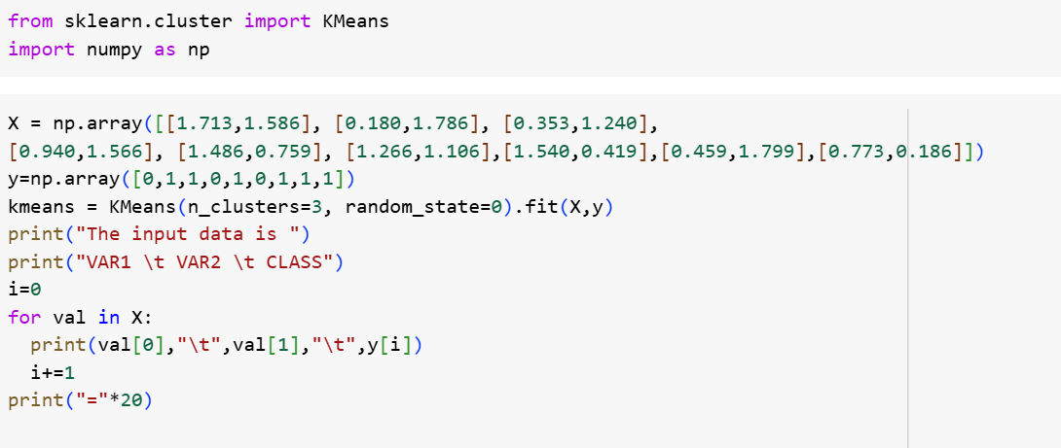
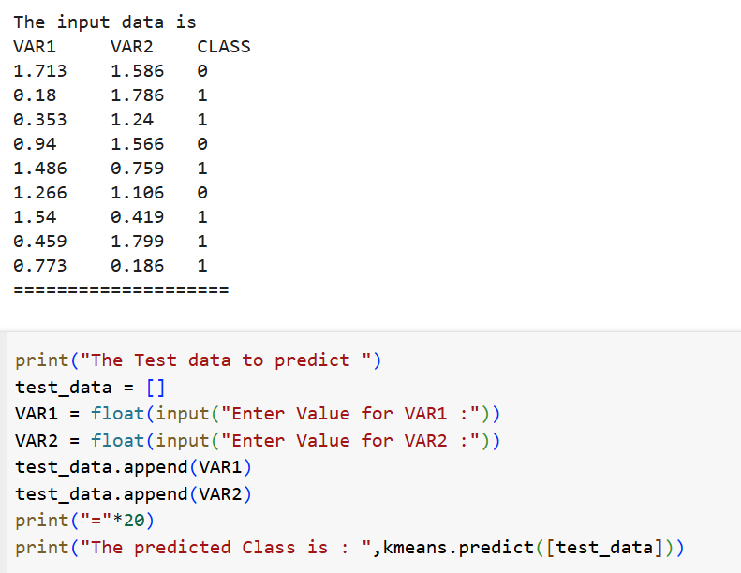
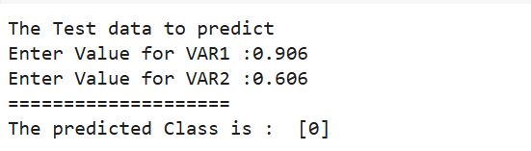
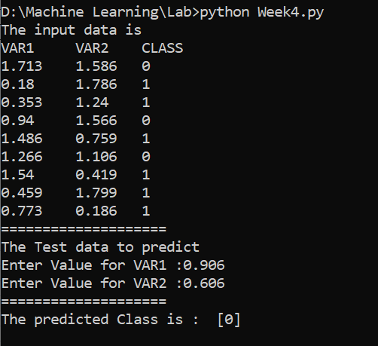

4.3VIVAQUESTIONS &ANSWERS

WhatisKmeansClusteringAlgorithm?

K Means algorithm is a centroid-based clustering (unsupervised) technique. This technique groups the dataset into k differentclusters having an almost equal number of points. Each of the clusters has a centroid point which represents the mean ofthe data points lying in that cluster.

The ideaoftheK-Meansalgorithmisto findk-centroidpointsandeverypoint inthedataset willbelong to either of the k-sets having minimum Euclidean distance.

IsFeatureScalingrequiredfortheKmeansAlgorithm?
Yes, K-Means typically needs to have some form of normalization done on the datasets to work properly since it is sensitive to boththe mean and variance ofthe datasets.
Forperforming featurescaling,generally, StandardScalerisrecommended,but dependingonthespecific use cases, other techniques might be more suitable as well.
For Example,let’s have 2 variables, named age and salary where age is in the range of 20 to 60 andsalaryis inthe range of100-150K, since scales of these variables are different so whenthese variables are substituted in the euclidean distance formula, then the variable which is on the large scale suppresses the variable which is onthe smaller scale. So, the impact of age will not be captured veryclearly. Hence, you have to scale the variables to the same range usingStandard Scaler, Min-MaxScaler, etc.

Whichmetricscanyouuseto findtheaccuracyoftheK meansAlgorithm?
Theredoesnot exist acorrectanswertothisquestionask meansbeing anunsupervised learningtechnique does not discuss anything about the output column. As a result, one can not get the accuracy number or values from the algorithm directly.

WhataretheadvantagesanddisadvantagesoftheK meansAlgorithm? Advantages:
  - Easytounderstandandimplement.
  - Computationallyefficientforbothtrainingandprediction.
  - Guaranteedconvergence.

Disadvantages:

  - Weneed toprovidethenumber ofclustersasaninputvariabletothe algorithm.
  - Itisverysensitivetotheinitializationprocess.
  - Goodat clusteringwhenwearedealing withsphericalcluster shapes, but it willperformpoorly when dealing with more complicated shapes.
  - DuetotheleveragingoftheEuclideandistancefunction,itissensitivetooutliers.

Whatare thewaystoavoidtheproblemofinitializationsensitivity intheK meansAlgorithm?
Therearetwowaysto avoidtheproblemofinitializationsensitivity:

  - RepeatKmeans: Itbasicallyrepeatsthealgorithmagainandagainalongwithinitializingthe centroidsfollowedbypickinguptheclusterwhichresultsinthesmallintraclusterdistanceandlarge

interclusterdistance.
  - KMeans++:Itisasmartcentroidinitializationtechnique.

Amongst theabovetwotechniques, K-Means++isthebestapproach.

PROGRAM5

5.TheFollowing Training ExamplesMap DescriptionsOfIndividualsOntoHigh,Medium And LowCredit-Worthiness.
mediumskiingdesignsingletwentiesno ->highRisk high golftrading married forties yes ->lowRisk
lowspeedwaytransportmarriedthirtiesyes->medRisk mediumfootballbanking single thirties yes ->lowRisk high flying media married fifties yes ->highRisk
low football security single twenties no ->medRisk medium golf media single thirties yes ->medRisk medium golf transport married forties yes ->lowRisk highskiingbankingsinglethirtiesyes->highRisklow golf unemployed married forties yes ->highRisk

SOURCECODE:

Input attributes are (from left to right) income, recreation,job, status,age-group, home- owner.Findtheunconditionalprobabilityof`golf'andtheconditionalprobabilityofsingle'given
`medRisk' in thedataset? totalRecords=10 numberGolfRecreation=4
probGolf=numberGolfRecreation/totalRecordsprint("Unconditional probability of golf: ={}".format(probGolf)) #conditional probability of `single' given`medRisk'
# bayes Formula #p(single|medRisk)=p(medRisk|single)p(single)/p(medRisk) #p(medRisk|single)=p(medRisk ∩single)/p(single)

#Thereforetheresultis:
numberMedRiskSingle=2 numberMedRisk=3
probMedRiskSingle=numberMedRiskSingle/totalRecordsprobMedRisk=numberMedRisk/totalRecordsconditionalProbability=(probMedRiskSingle/probMedRisk)
print("ConditionalprobabilityofsinglegivenmedRisk:={}".format(conditionalProbability))

OUTPUT:

Unconditionalprobabilityofgolf:=0.4
ConditionalprobabilityofsinglegivenmedRisk:=0.6666666666666667
Implementing in Code:

In the given data set,
The total number of records are 10.
The number of records which contains 'golf' are 4.
Then, the Unconditional probability of golf :
= The number of records which contains 'golf' / total number of records
= 4 / 10
= 0.4
To find the Conditional probability of single given medRisk,
Let S : single MR : medRisk
By the definition of Baye's rule( conditional probability ), we have
P(S ∣ MR) = P(S ∩ MR) / P(MR)
P(S ∩ MR) = The number of MedRisk with Single records / total number of Records
= 2 / 10 = 0.2
P(MR) = The number of records with MedRisk /total number of Records
= 3 / 10 = 0.3
The Conditional probability of single given medRisk
P(S ∣ MR) = 0.2 / 0.3 = 0.66666

Code:
total_Records=10
numGolfRecords=4
unConditionalprobGolf=numGolfRecords / total_Records
print("Unconditional probability of golf: ={}".format(unConditionalprobGolf))
#conditional probability of 'single' given 'medRisk'
numMedRiskSingle=2
numMedRisk=3
probMedRiskSingle=numMedRiskSingle/total_Records
probMedRisk=numMedRisk/total_Records
conditionalProb=(probMedRiskSingle/probMedRisk)
print("Conditional probability of single given medRisk: = {}".format(conditionalProb))
Output:
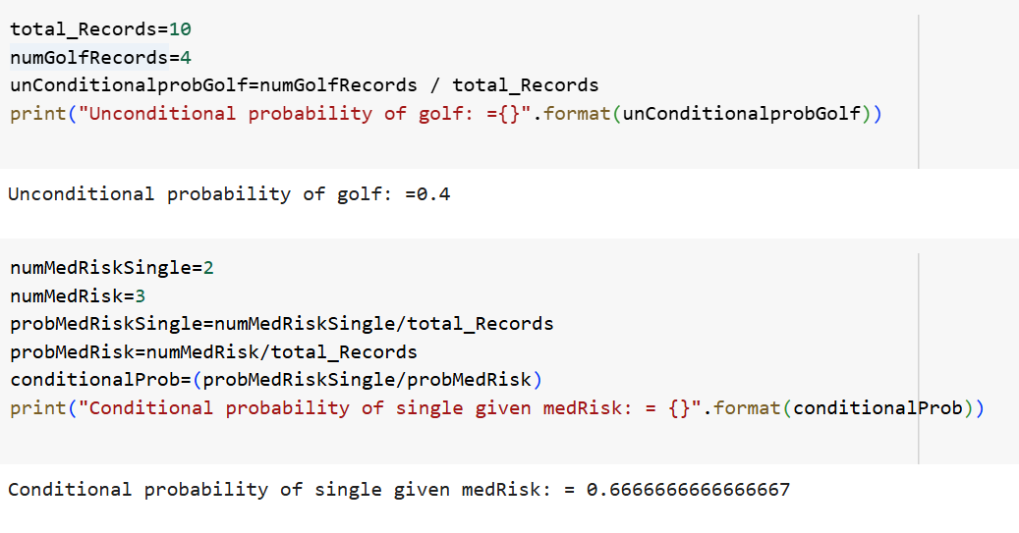
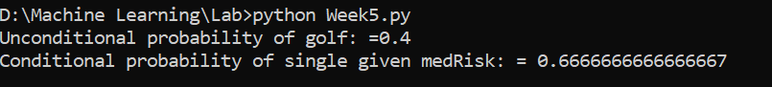

VIVAQUESTIONS&ANSWERS:

HowKmeans++clusteringAlgorithmworks?

KMeans++algorithmisasmarttechnique forcentroid initializationthat initializedonecentroidwhile ensuring the others to be far away fromthe chosen one resulting in faster convergence.
Thestepstofollow forcentroidinitializationare:

Step-1:Pickthe firstcentroidpointrandomly.

Step-2:Computethedistanceofallpoints inthedataset fromtheselected centroid. Thedistanceofxipoint fromthe farthest centroid can be calculated bythe given formula:

where,

di:Distanceofxipointfromthefarthestcentroid
m:numberofcentroidsalreadypicked

Step-3:Makethepointxiasthenewcentroidthatishavingmaximumprobabilityproportionaltodi

Step-4:Repeattheabovelasttwo stepstillyoufindk centroids.

Whatisthetraining andtestingcomplexityoftheKmeansAlgorithm?

Trainingcomplexityinterms ofBig-Onotation:
IfweuseLloyd’salgorithm,thecomplexityfortrainingis:“K*I*N*M”

where,

K: It represents the number ofclusters I:Itrepresentsthenumberofiterations N: It represents the sample size
M:Itrepresentsthe numberofvariables

Conclusion:ThereisasignificantImpactoncappingthenumberofiterations.

Predicting complexityintermsofBig-Onotation:

“K*N*M”
Predictionneedsto becomputedforeachrecord,thedistancetoeachclusterandassignedtothenearest ones.

Isitpossiblethattheassignment ofdatapointstoclustersdoesnotchangebetweensuccessive iterations in the K means Algorithm?
Whenthe K-Meansalgorithmhasreachedthe localorglobalminima, it willnot changetheassignmentof data points to clusters for two successive iterations during the algorithmrun.

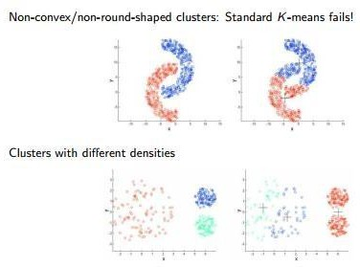

- HowtoChooseKValueinK-Means:

1. Elbow method
steps:

step1:computeclusteringalgorithmfordifferentvaluesofk. for example k=[1,2,3,4,5,6,7,8,9,10]
step2:foreachkcalculatethewithin-clustersumofsquares(WCSS). step3: plot curve of WCSS according to the number of clusters.
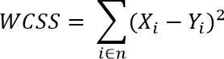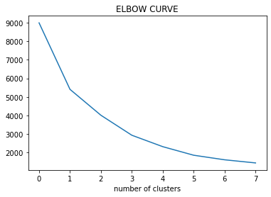step4: The location ofbend inthe plot is generally considered an indicator ofthe approximate number of clusters.

What arethepracticalConsiderationsInK-Means:
  - AchoosingnumberofClustersinAdvance(K).
  - StandardizationofData(scaling).
  - CategoricalData(canbesolvedwithK-Mode).
  - ImpactofinitialCentroidsandOutliers.

WhydoyoupreferEuclideandistance overManhattandistanceintheKmeansAlgorithm?

Euclidean distanceis preferred over Manhattan distance since Manhattan distance calculates distance only vertically or horizontally due to which it has dimension restrictions.

On the contrary, Euclidean distance can be used in any space to calculate the distances between the data points. Since inK means algorithm the data points can be present in any dimension, so Euclidean distance is a more suitable option.

PROGRAM 6:

6.IMPLEMENTLINEARREGRESSIONUSINGPYTHON. AIM:
ToImplementlinearregressionusingpython.

DESCRIPTION:

Regression: Regression analysis is one ofthe most important fields instatistics and machine learning.There are manyregression methods available. Linear regression is one ofthem

WhatIsRegression?
Regressionanalysisisoneofthe mostimportantfieldsinstatisticsand machine learning.Thereare manyregression methods available. Linear regression isone of them.Regressionsearchesforrelationshipsamongvariables.Forexample,youcanobserve several employees of some company and try to understandhow theirsalaries depend on the features,such as experience,level of education,role,city they work in,andso on.Thisis a regressionproblemwhere data related to each employee represent one observation.The presumptionisthattheexperience,education,role,andcityaretheindependentfeatures, while the salarydependsonthem.Generally, in regressionanalysis, you usuallyconsider some phenomenonofinterest andTherehave a number ofobservations. Eachobservation hastwo or more features. Following the assumption that(atleast)oneofthefeaturesdependsontheothers,youtrytoestablisharelationamongthem.youneed to find afunction thatmaps somefeatures or variables to others sufficiently well.The dependent featuresare called the dependent variables, outputs,or responses.The independent features are called the independent variables, inputs, or predictors.

LinearRegression:
Linear regression is probably one of the most important and widely used regression techniques. It’s among the simplest regression methods. One of its main advantages is the easeofinterpretingresults.When implementing linear regressionofsome dependent variable
𝑦on the set of independent variables x= (x1…xrᵣ),where ris the number of predictors, you assume a linear relationship between y andx: y= β0 + β1x1 + ……+ βrxr+ ϵ. This equation is theregressionequation.β0,,βrᵣaretheregressioncoefficients,and𝜀istherandomerror.
Linear regression calculates the estimators of the regression coefficients or simply the predicted weights,denotedwithb1…br.Theydefinetheestimatedregressionfunctionf(x)=b0+b1x1+

….+brxrThis function should capturethe dependencies between the inputsand output sufficiently well.

SimpleLinearRegression
Thefollowingfigureillustratessimplelinearregression:

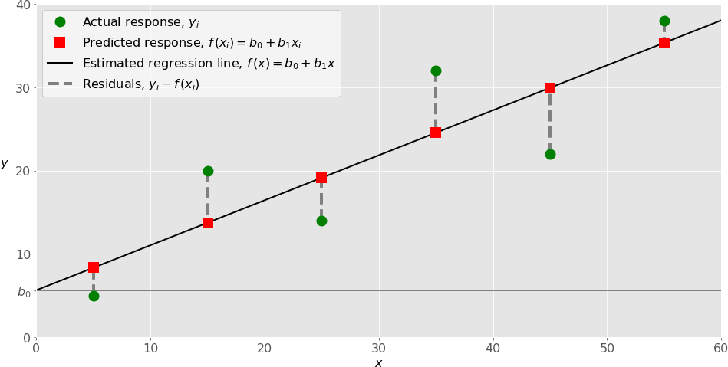

Whenimplementingsimple linearregression, youtypicallystart withagivenset ofinput-output (x-y) pairs (green circles). These pairs are your observations. For example, the leftmost observation(greencircle) hasthe input x=5andtheactualoutput(response)y=5.Thenextone has x= 15 and y= 20, and so on.

Theestimatedregressionfunction(blackline)hastheequationf(x)=b0+b1x.Yourgoalistocalculatetheopti malvaluesofthepredictedweightsb0andb1thatminimizeSSRanddetermine theestimatedregressionfunction.Thevalueofb0,alsocalledtheintercept,showsthepointwheretheestimatedregressionlinecrossesthe yaxis.Itisthevalueoftheestimatedresponse f(x)for x=0. Thevalueofb1 determinestheslopeoftheestimated regression line.

The predicted responses (red squares) are the points on the regression line that correspond to the input values. For example, for the input x= 5, the predicted response is f (5) = 8.33 (represented with the leftmost red square).
Theresiduals(verticaldashedgraylines)canbecalculatedasy1ᵢ-f(x1ᵢ)=y1–b0–b1x1fori=1,

…,n . They are the distances between the green circles and red squares. When you implement linear regression, you are actually trying to minimize these distances and make the red squares as close to the predefined green circles as possible.

ImplementingLinearRegressionin Python
It’s time to start implementing linear regression in Python. Basically, all you should do is apply the proper packages and their functions and classes.

PythonPackagesforLinearRegression
The package NumPyis a fundamental Python scientific package that allows many high- performanceoperationsonsingle-andmulti-dimensionalarrays.Italsooffersmanymathematical routines. Of course, it’s opensource.

Thepackagescikit-learnisawidely usedPythonlibrary formachinelearning,builton top of NumPy and some other packages. It provides the means for preprocessing data, reducing dimensionality,implementingregression,classification,clustering,andmore.LikeNumPy,scikit-learn is also opensource.

If you want to implement linear regression and need the functionality beyond the scope ofscikit- learn, you should consider statsmodels. It’s a powerful Python package for the estimation of statistical models, performing tests, and more. It’s open source as well.

SimpleLinearRegressionWithscikit-learn
Let’sstart withthesimplest case,whichissimplelinearregression.There are five basic steps when you’re implementing linear regression:
- Importthepackagesandclassesyouneed.
- Providedatato workwithand eventuallydoappropriatetransformations.
- Createaregressionmodelandfititwithexistingdata.
- Checktheresultsofmodelfitting toknowwhetherthemodelissatisfactory.
- Applythemodelforpredictions.

SOURCECODE:
importnumpy as npimportmatplotlib.pyplotasplt
defestimate_coef(x, y):
#numberofobservations/points n=

np.size(x)
#meanofxandyvector
m_x, m_y=np.mean(x),np.mean(y)

#calculatingcross-deviationanddeviationaboutxSS_xy= np.sum(y*x) - n*m_y*m_x
SS_xx=np.sum(x*x)-n*m_x*m_x

#calculatingregressioncoefficientsb_1=
SS_xy/SS_xx
b_0=m_y-b_1*m_xreturn(b_0, b_1)
defplot_regression_line(x,y,b):

#plottingtheactualpointsasscatterplot plt.scatter(x, y, color = "m",
marker= "o",s= 30)

#predictedresponsevectory_pred= b[0] + b[1]*x

# plotting the regression line plt.plot(x,y_pred,color="g")

#puttinglabels plt.xlabel('x')
plt.ylabel('y')

#functiontoshowplot plt.show()
defmain():
#observations

x=np.array([0,1, 2, 3, 4, 5,6, 7, 8,9])

y=np.array([1,3, 2, 5, 7, 8,8, 9, 10,12])

#estimatingcoefficientsb= estimate_coef(x, y)
print("Estimatedcoefficients:\nb_0={}\

\nb_1={}".format(b[0],b[1]))

# plotting regression line plot_regression_line(x,y,b)

ifname =="main": main()

OUTPUT:
Estimatedcoefficients: b_0=-0.05862068965

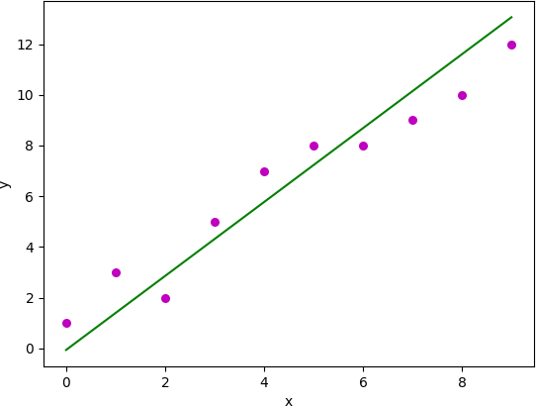

VIVAQUESTIONSANDANSWERS

WhatdoyoumeanbytheLogisticRegression?

It’s a classification algorithm that is used where the target variable is of categorical nature. The main objective behind Logistic Regression is to determine the relationship between features and the probability of a particular outcome.
For Example, when we need to predict whether a student passes or fails in an exam given the number of hours spent studying as a feature, the target variable comprises two values i.e. pass and fail.
Therefore, we can solve classification problem statements which is a supervised machine learning technique using Logistic Regression.

What arethedifferenttypesofLogisticRegression?

ThreedifferenttypesofLogisticRegressionareas follows:

- BinaryLogisticRegression:Inthis, thetargetvariablehasonlytwo2possible outcomes.

ForExample,0and1,orpassandfailortrue andfalse.

- MultinomialLogisticRegression: Inthis, thetargetvariablecanhavethreeormorepossible values without any order.

ForExample, Predictingpreferenceoffoodi.e. Veg,Non-Veg, Vegan.

- OrdinalLogisticRegression:Inthis,thetargetvariablecanhavethreeormorevalueswithordering.

ForExample,Movieratingfrom1to5.

Howdowehandle categoricalvariablesinLogisticRegression?

The inputs given to a Logistic Regression model need to be numeric. The algorithm cannot handle categorical variables directly. So, we need to convert the categorical data into a numerical format that is suitable for the algorithm to process.
Each level of the categorical variable will be assigned a unique numeric value also known as a dummy variable. These dummy variables are handled by the Logistic Regression model in the same manner asany other numeric value.

Whataretheassumptionsmadein LogisticRegression?

SomeoftheassumptionsofLogistic Regressionareas follows:

- Itassumesthatthereisminimalornomulticollinearityamongtheindependent variablesi.e, predictors are not correlated.
- Thereshouldbea linearrelationshipbetweenthe logitoftheoutcomeandeachpredictorvariable. The logitfunction is described as logit(p) = log(p/(1-p)), where p is the probabilityofthe targetoutcome.
- Sometimestopredictproperly,it usuallyrequiresa largesamplesize.

- TheLogisticRegressionwhichhasbinaryclassificationi.e,twoclassesassumethatthetarget variable is binary, and ordered Logistic Regression requires the target variable to be ordered.
Forexample, TooLittle, AboutRight,Too Much.

- Itassumesthereisnodependencybetweentheobservations.

CanwesolvethemulticlassclassificationproblemsusingLogisticRegression?IfYesthen How?

Yes, inorderto dealwith multiclassclassificationusing Logistic Regression,the most famous method is knownastheone-vs-allapproach. Inthisapproach, anumber ofmodelsaretrained, whichisequaltothe number of classes. These models work in a specific way.
ForExample, the first modelclassifies the data point depending onwhether it belongs to class 1 orsome otherclass(notclass1);thesecond modelclassifiesthedatapoint into class2orsomeotherclass(not class 2) and so-onfor allother classes. So, inthis manner, eachdatapoint can be checked over allthe classes.

PROGRAM7

IMPLEMENTNAÏVEBAYESTHEOREMTOCLASSIFYTHEENGLISHTEXT AIM:
ToImplementnaïvebaye’stheoremtoclassifytheEnglishtext

DESCRIPTION:
The challenge of text classification is to attach labels to bodies of text, e.g., tax document, medical form, etc. based on the text itself. For example, think of your spam folder in your email. How does your email provider know that a particular message is spam or “ham” (not spam)? We’ll take a look at one natural language processing technique for text classification called Naive Bayes

SOURCE CODE:
importpandasaspd

fromsklearn.model_selection import train_test_splitfromsklearn.feature_extraction.text import CountVectorizerfrom sklearn.naive_bayes import MultinomialNB
fromsklearn.metricsimportaccuracy_score,confusion_matrix,precision_score,recall_score

msg=pd.read_csv('document.csv',names=['message','label']) print("Total Instances of Dataset: ", msg.shape[0]) msg['labelnum'] = msg.label.map({'pos': 1, 'neg': 0})
X=msg.message y=msg.labelnum
Xtrain,Xtest,ytrain,ytest=train_test_split(X,y) count_v = CountVectorizer()

Xtrain_dm= count_v.fit_transform(Xtrain) Xtest_dm = count_v.transform(Xtest)
df=pd.DataFrame(Xtrain_dm.toarray(),columns=count_v.get_feature_names())

clf = MultinomialNB() clf.fit(Xtrain_dm, ytrain) pred=clf.predict(Xtest_dm)
print('AccuracyMetrics:')

print('Accuracy:',accuracy_score(ytest,pred))print('Recall:',recall_score(ytest,pred))print('Precision:', precision_score(ytest, pred))
print('ConfusionMatrix:\n',confusion_matrix(ytest,pred))

document.csv:

Ilovethissandwich,posThis is an amazingplace,pos
Ifeelverygoodaboutthesebeers,pos This is my best work,pos
Whatanawesomeview,pos

Idonotlikethisrestaurant,neg I am tired of this stuff,neg
Ican'tdealwiththis,negHe ismyswornenemy,negMy

bossishorrible,neg
Thisisanawesomeplace,pos

Ido notlikethetasteofthisjuice,neg I love to dance,pos
Iamsickandtiredofthisplace,neg What a great holiday,pos
Thatisabadlocalitytostay,neg
Wewillhavegoodfuntomorrow,posI went to my enemy's house today,neg

OUTPUT:

TotalInstancesofDataset:18 AccuracyMetrics:
Accuracy:0.6
Recall:0.6666666666666666

Precision:0.6666666666666666

ConfusionMatrix: [[1 1]
[12]]

VIVAQUESTIONS&ANSWERS

HowNaiveBayesalgorithmworks?
Let’sunderstand it using anexample. Below I have atraining datasetofweather and corresponding target variable ‘Play’ (suggesting possibilities ofplaying). Now, weneed to classifywhether players willplayor not based onweather condition. Let’s follow the below stepsto perform it.

Step1:Convertthedatasetintoafrequencytable
Step2:CreateLikelihoodtablebyfindingtheprobabilitieslikeOvercast probability=0.29and probability of playing is 0.64.
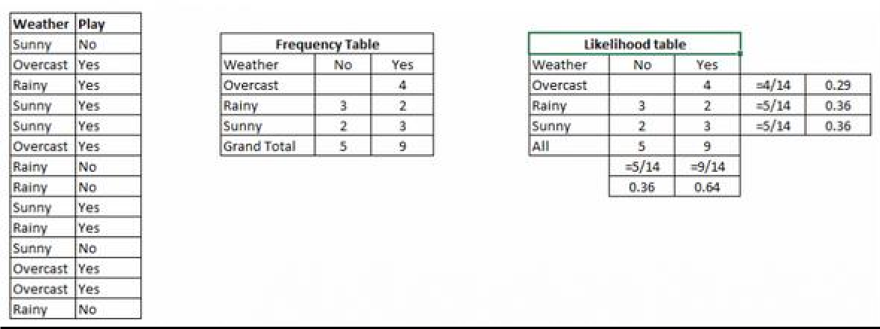
Step3:Now,useNaiveBayesianequationtocalculatetheposteriorprobabilityforeachclass. Theclass with the highest posterior probability is the outcome of prediction.
Problem:Playerswillplayifweather issunny.Isthisstatement iscorrect? We can solve it using above discussed method ofposterior probability.
P(Yes| Sunny)=P(Sunny| Yes) *P(Yes) /P(Sunny)

HerewehaveP(Sunny|Yes) =3/9=0.33,P(Sunny) =5/14=0.36,P(Yes)=9/14=0.64 Now, P (Yes | Sunny) = 0.33 * 0.64 / 0.36 = 0.60, which has higher probability.
NaiveBayesusesasimilar methodto predicttheprobabilityofdifferent classbasedonvariousattributes. This algorithm is mostlyused intext classification and withproblems having multiple classes.

Applications ofNaiveBayesAlgorithms
  - Real time Prediction: Naive Bayes is an eager learning classifier and itis sure fast. Thus, it could be used for making predictions in real time.
  - Multi class Prediction: This algorithm is also well known for multi class prediction feature. Here we can predict the probabilityof multiple classes of target variable.
  - Text classification/ Spam Filtering/ Sentiment Analysis: Naive Bayes classifiers mostly used in text classification(due to better result in multiclass problems and independence rule) have higher success rateas compared tootheralgorithms. As a result, it is widelyused inSpamfiltering (identifyspame-mail) and Sentiment Analysis (in social media analysis, to identifypositive and negative customer sentiments)
  - Recommendation System: Naive Bayes Classifier and Collaborative Filtering together builds a Recommendation System that uses machine learning and data mining techniques to filter unseen information and predict whether a user would like a given resource or not

PROGRAM8

IMPLEMENTANALGORITHMTODEMONSTRATETHESIGNIFICANCEOF GENETICALGORITHM

AIM:
ToImplementanalgorithmtodemonstratethesignificance ofgeneticalgorithm

DESCRIPTION:
Genetic Algorithms (GAs) are adaptive heuristic search algorithms that belong to the larger part of evolutionary algorithms. Genetic algorithms are based on the ideas of natural selection and genetics. These are intelligent exploitation of random search provided with historicaldata to direct the search into the region of better performance in solution space. They are commonly used to generate high-quality solutions for optimization problems and search problems.Genetic algorithms simulate the process of natural selection which means those specieswho canadapt tochanges intheir environment areableto surviveandreproduceandgo to next generation. In simple words, they simulate “survival of the fittest” among individual of consecutive generation for solving a problem. Each generation consist of a population of individuals and each individual represents a point in search space and possible solution. Each individual is represented as a string of character/integer/float/bits. This stringis analogous to the Chromosome.Genetic algorithms are based on an analogy with genetic structure and behavior of chromosome of the population. Following is the foundation of GAs based on this analogy –
  - Individualinpopulationcompeteforresourcesandmate
  - Those individuals whoare successful (fittest) then mate tocreate more offspring than others
  - Genesfrom“fittest”parent propagatethroughoutthegeneration,that issometimes parents create offspring which is better than either parent.
  - Thuseachsuccessivegeneration ismoresuitedfortheir environment.
The population of individuals are maintained within search space. Each individualrepresent a solution in search space for given problem. Each individual is coded as a finite length vector(analogoustochromosome)ofcomponents.Thesevariablecomponentsare

analogousto Genes.Thusachromosome(individual) iscomposedofseveralgenes(variable components)

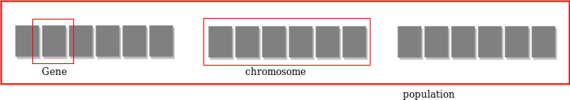

A Fitness Score is given to each individual whichshows the ability ofanindividual to “compete”. The individual having optimal fitness score (or near optimal) are sought.The GAs maintains the population of n individuals (chromosome/solutions) along with their fitness scores.The individuals having better fitness scores are given more chance to reproduce than others. The individuals with better fitness scores are selected who mate and produce better offspring by combining chromosomes of parents. The population size is static so the room has to be created for new arrivals. So, someindividuals die and get replacedby new arrivals eventually creating new generation when all the mating opportunity of the old population is exhausted. It is hoped that over successive generations better solutions willarrive while least fit die.Each new generation has on average more “better genes” than the individual (solution)of previousgenerations.Thuseachnewgenerationshavebetter“partial solutions” than previous generations. Once the offsprings produced having no significant difference than offspring produced by previous populations, the population is converged. The algorithm is said to be converged to a set ofsolutions for the problem.

OPERATORSOFGENETICALGORITHM:
Oncethe initialgenerationiscreated,thealgorithmevolvethegenerationusing following operators –
- SelectionOperator: The idea istogivepreferencetothe individualswithgoodfitness scores and allow themto pass there genes to the successive generations.
- Crossover Operator: This represents mating between individuals. Two individuals are selected using selection operator and crossover sites are chosen randomly. Then the genes at thesecrossoversitesareexchangedthuscreatingacompletelynew individual(offspring).For example –

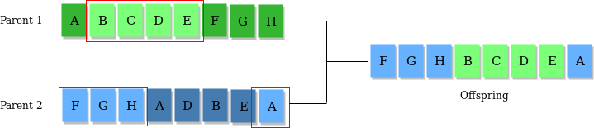

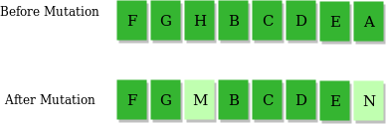
MutationOperator:Thekeyidea istoinsert randomgenesinoffspringtomaintainthe diversity in population to avoid the premature convergence. For example –

ALGORITHM:
- Randomlyinitializepopulationsp
- Determinefitnessofpopulation
- Untillconvergencerepeat:
  - Selectparentsfrompopulation
  - Crossoverandgeneratenewpopulation
  - Performmutationonnewpopulation
  - Calculatefitnessfornewpopulation

USESOFGENETIC ALGORITHM:
- TheyareRobust
- Provideoptimisationoverlargespacestate.
- UnliketraditionalAI,theydonotbreakonslightchangeininputorpresenceofnoise

SOURCECODE:
importnumpydefcal_pop_fitness(equation_inputs,pop):
#Calculatingthefitnessvalueofeachsolutioninthecurrentpopulation.

#Thefitness functioncalulatesthesumofproductsbetweeneachinput and its corresponding weight.
fitness=numpy.sum(pop*equation_inputs, axis=1) return fitness
defselect_mating_pool(pop,fitness,num_parents):

#Selectingthebest individuals inthecurrent generationasparentsforproducingthe offspring of the next generation.
parents=numpy.empty((num_parents, pop.shape[1])) for parent_num in range(num_parents):
max_fitness_idx=numpy.where(fitness== numpy.max(fitness)) max_fitness_idx = max_fitness_idx[0][0]parents[parent_num, :] = pop[max_fitness_idx, :] fitness[max_fitness_idx] = -99999999999
returnparents
def crossover(parents, offspring_size): offspring = numpy.empty(offspring_size)

#Thepoint at whichcrossovertakesplacebetweentwo parents.Usually, it isatthecenter. crossover_point = numpy.uint8(offspring_size[1]/2)
for kinrange(offspring_size[0]):

#Indexofthefirst parentto mate. parent1_idx = k%parents.shape[0]
# Index of the second parent to mate. parent2_idx=(k+1)%parents.shape[0]
#Thenewoffspringwillhave itsfirst halfofitsgenestakenfromthe first parent. offspring[k, 0:crossover_point] = parents[parent1_idx, 0:crossover_point]
#Thenewoffspringwillhave itssecondhalfofits genestakenfromthesecondparent. offspring[k, crossover_point:] = parents[parent2_idx, crossover_point:]
returnoffspring

defmutation(offspring_crossover,num_mutations=1):

mutations_counter=numpy.uint8(offspring_crossover.shape[1]/num_mutations)

#Mutationchangesanumberofgenesasdefined bythe num_mutations argument. The changes are random.
foridx in range(offspring_crossover.shape[0]): gene_idx = mutations_counter - 1 formutation_numinrange(num_mutations): # The randomvaluetobeaddedtothegene.

random_value=numpy.random.uniform(-1.0,1.0, 1)
offspring_crossover[idx, gene_idx] = offspring_crossover[idx, gene_idx] + random_value
gene_idx = gene_idx + mutations_counterreturn offspring_crossover
importnumpy

"""
The y=target is to maximize this equation ASAP: y = w1x1+w2x2+w3x3+w4x4+w5x5+6wx6 where(x1,x2,x3,x4,x5,x6)=(4,-2,3.5,5,- 11,-4.7)
Whatarethebestvaluesforthe6weightsw1tow6?
Wearegoingto usethegeneticalgorithmforthebest possiblevaluesaftera number of generations.
"""
#Inputsoftheequation. equation_inputs = [4,-
2,3.5,5,-11,-4.7]

# Number of the weights we are looking to optimize.num_weights=len(equation_inputs)

"""
Genetic algorithm parameters:Mating pool size Population size
"""

sol_per_pop=8

num_parents_mating= 4
#Definingthepopulationsize.
pop_size=(sol_per_pop,num_weights)#Thepopulationwillhavesol_per_pop chromosome where each chromosome has num_weights genes.
#Creatingthe initialpopulation.
new_population=numpy.random.uniform(low=-4.0,high=4.0, size=pop_size) print(new_population)
"""

new_population[0,:]=[2.4,0.7,8,-2,5,1.1]
new_population[1,:]=[-0.4,2.7,5,-1,7,0.1]

new_population[2,:]=[-1,2,2,-3,2,0.9]
new_population[3,:]=[4, 7,12,6.1,1.4,-4]

new_population[4,:]=[3.1,4,0,2.4, 4.8,0]

new_population[5,:]=[-2,3,-
7,6,3, 3]"""

best_outputs = [] num_generations= 1000
for generation in range(num_generations):
print("Generation:", generation)
# Measuring the fitness of each chromosome in the population.fitness=cal_pop_fitness(equation_inputs, new_population) print("Fitness")
print(fitness) best_outputs.append(numpy.max(numpy.sum(new_population*equation_inputs,
axis=1)))#Thebestresultinthecurrentiteration.
print("Bestresult:",numpy.max(numpy.sum(new_population*equation_inputs,axis=1)))

#Selectingthebest parentsinthepopulationfor mating. parents = select_mating_pool(new_population, fitness, num_parents_mating)
print("Parents ")
print(parents)

#Generatingnextgenerationusing

crossover.offspring_crossover= crossover(parents,
offspring_size=(pop_size[0]-parents.shape[0],num_weights))

print("Crossover") print(offspring_crossover)
#Addingsomevariationstotheoffspringusingmutation. offspring_mutation = mutation(offspring_crossover, num_mutations=2) print("Mutation") print(offspring_mutation)
#Creatingthenewpopulationbasedontheparentsandoffspring. new_population[0:parents.shape[0], :] = parents new_population[parents.shape[0]:, :] = offspring_mutation
#Gettingthebestsolutionafteriteratingfinishingallgenerations. #At first, the fitness is calculated for each solution in the final generation. fitness = cal_pop_fitness(equation_inputs, new_population)
#Thenreturnthe indexofthat solutioncorrespondingtothe best fitness. best_match_idx = numpy.where(fitness == numpy.max(fitness))
print("Bestsolution:",

new_population[best_match_idx,:])print("Best solution fitness : ", fitness[best_match_idx]) importmatplotlib.pyplotmatplotlib.pyplot.plot(best_outp
uts) matplotlib.pyplot.xlabel("Ite ration") matplotlib.pyplot.ylabel("Fit ness") matplotlib.pyplot.show()

OUTPUT:

[[0.582041412.32880696-2.951302092.570569533.33055238-0.58167871] [-1.65052225
3.52263842-2.46577305-1.7005396-3.804802020.29677167] [ 2.6239874-2.01548549-
1.722922953.61090243-1.25604726-2.32647264][-3.451673932.857718253.74655682-
2.017906260.25750106-3.12923247][2.86026334-0.4306777-3.262979561.74863348-
1.93705571-3.18855672][-1.700120890.98685104-1.911920723.91873942-0.09354385
1.43038667] [0.31769009-0.872908093.752497852.576579930.588830822.83231871][
3.833149260.33838112-2.49509594-1.507631743.99440509-0.03037715]]

Gen eration :
0
Fitness
[-33.708344139.6777259451.30214363-4.6238336545.91897711-1.566046069.24418172-

45.41084308]
Best result:
51.302143629097614
Parents
[[2.6239874-2.01548549-1.722922953.61090243-1.25604726-2.32647264][2.86026334-
0.4306777-3.262979561.74863348-1.93705571-3.18855672][-1.650522253.52263842-
2.46577305-1.7005396-3.804802020.29677167][0.31769009-0.872908093.75249785
2.576579930.58883082 2.83231871]]

Crossover

[[2.6239874-2.01548549-1.722922951.74863348-1.93705571-3.18855672][2.86026334-
0.4306777-3.26297956-1.7005396-3.804802020.29677167] [-1.650522253.52263842-
2.46577305 2.576579930.588830822.83231871][0.31769009-0.872908093.75249785
3.61090243-1.25604726-2.32647264]]

Mutation

[[2.6239874-2.01548549-1.678966321.74863348-1.93705571-3.97789372][2.86026334-
0.4306777-3.12878279-1.7005396-3.80480202-0.15430324][-1.650522253.52263842-
3.37669601 2.576579930.588830822.25153466][0.31769009-0.872908092.93428907
3.61090243-1.25604726-2.71597954]]
.
.

.

.

Generation:999
Fitness

[2554.39355622551.72360738 2549.405839542549.299316292552.24225166
2550.45506206
2547.12995122551.22467397]

Best result:
2554.3935561987346
Parents
[[3.17690088e-01-8.72908094e-012.67689952e+021.74863348e+00- 1.93705571e+00 -3.37108802e+02][3.17690088e-01 -8.72908094e-01
2.67638232e+021.74863348e+00-
1.93705571e+00-3.36689592e+02][3.17690088e-01-8.72908094e-012.67254110e+02
1.74863348e+00-1.93705571e+00-3.36865291e+02][3.17690088e-01-8.72908094e-01
2.67370854e+021.74863348e+00-1.93705571e+00-3.36672197e+02]]
Crossover

[[3.17690088e-01-8.72908094e-012.67689952e+021.74863348e+00- 1.93705571e+00 - 3.36689592e+02]
[3.17690088e-01-8.72908094e-012.67638232e+021.74863348e+00

-1.93705571e+00-3.36865291e+02]

[3.17690088e-01-8.72908094e-012.67254110e+021.74863348e+00

-1.93705571e+00-3.36672197e+02]

[3.17690088e-01-8.72908094e-012.67370854e+021.74863348e+00

-1.93705571e+00-3.37108802e+02]]

Mutation

[[3.17690088e-01-8.72908094e-01 2.68382875e+021.74863348e+00

-1.93705571e+00-3.36222272e+02]

[3.17690088e-01-8.72908094e-012.68456819e+021.74863348e+00

-1.93705571e+00-3.37417363e+02]

[3.17690088e-01-8.72908094e-012.67606746e+021.74863348e+00

-1.93705571e+00-3.36866918e+02]
[3.17690088e-01-8.72908094e-012.67051753e+021.74863348e+00

-1.93705571e+00-3.37331663e+02]]
Bestsolution:[[[3.17690088e-01-8.72908094e-012.68456819e+021.74863348e+00

-1.93705571e+00- 3.37417363e+02]]]

Bestsolutionfitness
:[2558.52782726]

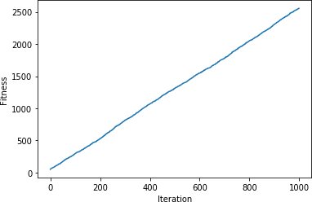

VIVAQUESTIONS&ANSWERS

What isaGeneticAlgorithm?

Let’sgetbacktotheexamplewediscussedaboveandsummarizewhatwedid.
- Firstly,wedefinedourinitialpopulationasourcountrymen.
- Wedefinedafunctiontoclassifywhetherisapersonisgoodorbad.

- Thenweselectedgoodpeopleformatingtoproducetheiroff-springs.
- Andfinally,theseoff-springsreplacethe badpeople fromthepopulationandthisprocess repeats.

PROGRAM9

IMPLEMENTTHEFINITEWORDSCLASSIFICATIONSYSTEMUSINGBACK- PROPAGATIONALGORITHM

AIM:
ToimplementthefinitewordsclassificationsystemusingBack-propagationalgorithm

DESCRIPTION:

Whatisbackpropagation?
We can define the backpropagation algorithm as an algorithm that trains some given feed- forward Neural Network for a given inputpattern wherethe classifications are known tous. At the point when every passage of the example set is exhibited to the network, the network looks at its yield reaction to the example input pattern. After that,thecomparison done between output response and expected output with the error value is measured.Later,weadjust the connection weight based upon the error value measured.
It was first introduced in the 1960s and 30 years later it was popularized by David Rumelhart, Geoffrey Hinton, and Ronald Williamsin the famous 1986 paper. In this paper, they spoke about the various neural networks. Today, back propagation is doing good. Neural network training happens through back propagation. By this approach, wefine-tunethe weights of a neural netbased on the errorrateobtained in the previous run. The rightmanner of applying this technique reduces error rates and makes the model more reliable. Backpropagationis used totrain theneural network of thechain rulemethod.In simple terms,aftereachfeed-forwardpassesthroughanetwork,thisalgorithmdoesthebackward

pass to adjust the model’s parameters based on weights and biases. A typical supervised learning algorithm attempts to find a function that maps input data to the right output. Back propagation works with a multi-layered neural network and learns internal representations of input to output mapping.
The Back propagation algorithm is a supervised learning method for multilayer feed- forward networks from the field of Artificial Neural Networks.
Feed-forward neuralnetworksare inspired bythe informationprocessing ofone or more neural cells, called a neuron. Aneuronaccepts input signals via its dendrites, whichpass the electrical signal down to the cell body. The axon carries the signal out to synapses, which are the connections of a cell’s axon to other cell’s dendrites.
The principle of the backpropagation approach is to model a given function by modifying internal weightings of input signals to produce an expected output signal.The system is trained using a supervised learning method, where the error between the system’s output and a known expected output is presented to the system and used to modify its internal state.
Technically, the backpropagationalgorithmis a method for training the weights in a multilayer feed-forward neural network. As such, it requires a network structure to be defined of one or more layers where one layeris fully connected to the nextlayer. A standard network structure is one input layer, one hidden layer, and one outputlayer.Back propagation can be used for both classification and regression problems.
In classification problems, best results are achieved when the network has one neuron in the output layer for each class value. For example, a 2-class or binary classification problem with the class values of A and B. These expected outputs would have to be transformed into binary vectorswithonecolumnfor eachclass value. Suchas[1,0]and[0, 1] for AandBrespectively. This is called a one hot encoding.

Howdoesbackpropagationwork?

Letustakealookathowbackpropagationworks.Ithasfourlayers: input layer,hiddenlayer, hidden layer II and final output layer.
So,themainthreelayersare:

- Inputlayer
- Hiddenlayer
- Outputlayer
Each layer has its own way of working and its own way to take action such that we are able to get the desired results and correlate these scenarios to our conditions. Let us discuss other details needed to help summarizing this algorithm.

SOURCE CODE:
importpandasaspd

fromsklearn.model_selection import train_test_splitfromsklearn.feature_extraction.text import CountVectorizer from sklearn.neural_network import MLPClassifier
fromsklearn.metricsimportaccuracy_score,confusion_matrix,precision_score,recall_score

msg = pd.read_csv('document.csv', names=['message','label'])print("TotalInstancesof Dataset: ", msg.shape[0]) msg['labelnum'] = msg.label.map({'pos': 1, 'neg': 0})
X=
msg.message y

=
msg.labelnum
Xtrain,Xtest,ytrain,ytest =train_test_split(X,y)

count_v = CountVectorizer() Xtrain_dm = count_v.fit_transform(Xtrain) Xtest_dm= count_v.transform(Xtest)
df=pd.DataFrame(Xtrain_dm.toarray(),columns=count_v.get_feature_names())

clf=MLPClassifier(solver='lbfgs',alpha=1e-5,hidden_layer_sizes=(5,2),random_state=1)

clf.fit(Xtrain_dm, ytrain)pred=clf.predict(Xtest_dm) print('AccuracyMetrics:')
print('Accuracy:',accuracy_score(ytest,pred))print('Recall:',recall_score(ytest,pred)) print('Precision: ', precision_score(ytest, pred))
print('ConfusionMatrix:\n',confusion_matrix(ytest,pred))

document.csv:

I love this sandwich,posThis is an amazingplace,pos

Ifeelverygoodaboutthese beers,pos This is my best work,pos
Whatanawesomeview,pos I do not like this restaurant,neg I am
tiredofthisstuff,neg I can't deal with this,neg He is
my sworn enemy,negMy boss is horrible,neg
Thisisanawesomeplace,pos I do not like the taste of
thisjuice,negIloveto dance,pos
Iamsickandtiredofthis place,neg What a great holiday,pos
Thatisabadlocalitytostay,neg We will have good fun
tomorrow,posIwenttomy

enemy'shousetoday,neg

OUTPUT:
TotalInstances of Dataset: 18 AccuracyMetrics:
Accuracy:0.8

Recall:1.0 Precisio
n:0.75
Confusion Matrix:
[[11]
[03]

VIVAQUESTIONS&ANSWERS:

- WhatisthedifferencebetweenaPerceptronandLogisticRegression?

A Multi-Layer Perception (MLP) is one of the most basic neuralnetworks that we use for classification. Forabinaryclassificationproblem, weknowthattheoutput canbeeither 0or1. This is just like our simple logistic regression, where we use a logit function to generate a probability between 0 and 1.

So,what’sthedifferencebetweenthetwo?

Simplyput,it isjust thedifference inthethreshold function!Whenwerestrictthe logistic regression modelto give us either exactly1 or exactly0, we get aPerception model:

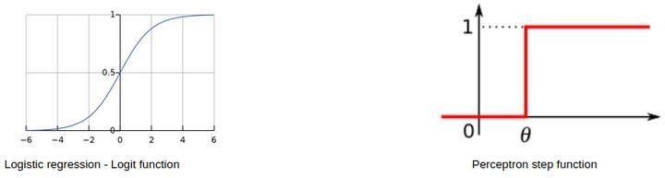

Canwe havethesame bias forallneurons ofahidden layer?

Essentially, youcanhaveadifferentbiasvalueateachlayerorateachneuronaswell. However, it is best ifwe have a bias matrix for all the neurons inthe hidden layers aswell.
Apoint tonoteisthatboththesestrategieswould giveyou verydifferentresults.

What ifwedonotuse anyactivationfunction(s)ina neuralnetwork?

Themain aim of thisquestionistounderstandwhy weneedactivationfunctionsin aneural network. You can start off bygiving a simple explanation of how neural networks are built:
Step 1: Calculate the sumofall the inputs (X) according to their weights andinclude the bias term:
Z= (weights * X)+ bias

Step2:Applyanactivationfunctionto calculatetheexpectedoutput: Y = Activation(Z)
Steps1and2areperformed at eachlayer. Ifyourecollect,this isnothing but forward propagation! Now, what if there is no activation function?
OurequationforYessentiallybecomes:

Y = Z= (weights *X)+ bias

Wait – isn’t this just a simple linear equation? Yes – and that is why we need activation functions. A linear equationwillnot be able to capturethe complexpatterns inthe data –this is even more evident in the case ofdeep learning problems.
In order to capture non-linear relationships, we use activation functions, and thatis why a neural network without anactivation function is just a linear regression model.

- Inaneuralnetwork, whatifalltheweightsareinitializedwiththesamevalue?

In simplest terms, if all the neurons have the same value of weights, each hidden unit will get exactly the same signal. While this might work during forward propagation, the derivative of the cost function during backward propagation would be the same everytime.

In short, there is no learning happening by the network! What do you call the phenomenon of the model being unable to learn any patterns fromthe data? Yes, under fitting.
Therefore,ifallweightshavethesameinitialvalue,thiswouldleadtounderfitting.

- What istheroleofweightsandbiasinaneuralnetwork?

This is a question best explained with a real-life example. Consider that you want to go out today to play a cricket match with your friends. Now, a number of factors can affect your decision-making, like:

  - Howmanyofyourfriendscanmakeittothegame?
  - Howmuchequipmentcanallofyoubring?
  - Whatisthetemperatureoutside?
Andso on.These factorscanchange yourdecisiongreatlyornottoo much.Forexample, ifit is rainingoutside, thenyoucannotgooutto playat all. Or ifyouhaveonlyone bat, youcanshare it while playing aswell. The magnitude bywhichthese factorscanaffect the game iscalled the weight of that factor.

Factors like the weather or temperature might have a higher weight, and other factors like equipment would have a lower weight.
However, does this mean that we can play a cricket match with only one bat? No – we would need 1 ball and 6 wickets as well. This is where bias comes into the picture. Bias letsyou assign some threshold which helps you activate a decision-point (or a neuron) only when that threshold is crossed.

PROGRAM 10 (a)
Aim:Build SVM model with various kernels and selec tbest kernel for given dataset.

SoftwareRequired:Google CoLab,Jupyter note book,Kaggle.
Dataset:https://www.kaggle.com/datasets/uciml/human-activity-recognition-with-smartphones

About Dataset The Human Activity Recognition database was built from the recordings of 30 study participants performing activities of daily living (ADL) while carrying a waist-mounted smartphone with embedded inertial sensors. The objective is to classify activities into one of the six activities performed.
Description of experimentThe experiments have been carried out with a group of 30 volunteers within an age bracket of 19-48 years. Each person performed six activities (WALKING, WALKINGUPSTAIRS,WALKINGDOWNSTAIRS,SITTING,STANDING,LAYING)wearinga
smartphone(SamsungGalaxyS II)onthewaist. Usingitsembeddedaccelerometer andgyroscope, we captured 3-axial linear acceleration and 3-axial angular velocity at a constant rate of 50Hz. The experiments have been video-recorded to label the data manually. The obtained dataset has been randomly partitioned into two sets, where 70% of the volunteers was selected for generating the training data and 30% the test data.
The sensor signals (accelerometer and gyroscope) were pre-processed by applying noise filters and then sampled in fixed-width sliding windows of 2.56 sec and 50% overlap (128 readings/window).The sensor acceleration signal, which has gravitational and body motion components, was separated using a Butterworth low-pass filter into body acceleration and gravity. The gravitational force is assumed to have only low frequency components, therefore a filter with 0.3 Hz cutoff frequency was used. From each window, a vector of features was obtained by calculating variables fromthetimeand frequency domain.
Attributeinformation
Foreachrecordinthedataset thefollowingisprovided:
Triaxialaccelerationfromtheaccelerometer (totalacceleration)andtheestimatedbodyacceleration. Triaxial Angular velocity from the gyroscope.
A561-featurevector withtimeandfrequencydomainvariables. Its activity label.
Anidentifierofthesubjectwhocarriedout theexperiment.

Theory:
SupportVectorMachineor SVMis oneofthemost popularSupervisedLearningalgorithms, which is used for Classification as well as Regression problems. However, primarily, it is used for Classification problems in Machine Learning.

The goal of the SVM algorithm is to create the best line or decision boundary that can segregate n- dimensionalspaceintoclasses sothat wecan easilyput thenew data point inthecorrect categoryin the future. This best decision boundary is called a hyperplane.

SVM chooses the extreme points/vectors that help in creating the hyperplane. These extreme cases are called as support vectors, and hence algorithm is termed as Support Vector Machine. Consider the below diagram in which there are two different categories that are classified using a decision boundary or hyperplane:
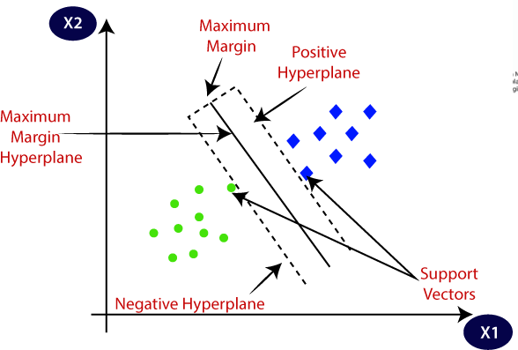

Example: SVM can be understood with the example that we have used in the KNN classifier. Suppose we see a strange cat that also has some features ofdogs, so ifwe want a modelthat canaccuratelyidentifywhether it is a cator dog, so sucha modelcanbe created by using the SVM algorithm. We will first train our model with lots of images of cats and dogs so that it can learn about different features of cats and dogs, and then we test it with this strange creature. So as support vector creates a decision boundary between these two data (cat and dog) and choose extreme cases (support vectors), it will see the extreme case of cat and dog. Onthe basis of the support vectors, it willclassify it as a cat.
Considerthebelowdiagram:
TypesofSVM
SVMcanbeoftwo types:

- Linear SVM: Linear SVM is used for linearly separable data, which means if a dataset can be classified into two classes by using a single straight line, then such data is termed as linearly separable data, and classifier is used called as Linear SVM classifier.
- Non-linear SVM: Non-Linear SVM is used for non-linearly separated data, which means if a dataset cannot be classified by using a straight line, then such dataistermed asnon-linear dataand classifier used iscalled asNon-linear SVM classifier.

HyperplaneandSupport Vectorsin theSVM algorithm:

Hyperplane: There can be multiple lines/decision boundaries to segregate the classes in n- dimensional space, but we need to find out the best decision boundarythat helps to classify the data points. This best boundary is known as the hyperplane of SVM.

The dimensions of the hyperplane depend on the features present in the dataset, which meansifthereare2features(asshowninimage),thenhyperplanewillbeastraightline.

And ifthereare3features,thenhyperplanewill bea2-dimensionplane.

We always create a hyperplane that has a maximum margin, which means the maximum distance between the data points.

SupportVectors:

The data points or vectors that are the closest to the hyperplane and which affect the position of the hyperplane are termed as Support Vector. Since these vectors support the hyperplane, hence called a Support vector.

Program:

#Import required basic libraries importnumpyasnp#linearalgebra
importpandasaspd#dataprocessing,CSVfileI/O(e.g.pd.read_csv) import os

# Read dataset into dataframe data=pd.read_csv('/kaggle/input/human-activity-recognition-with- smartphones/train.csv')
data.describe() data

data.info() data.columns
data.Activity.value_counts() data.shape
data['activity_code']=data.Activity.astype('category').cat.codes data.shape
data.activity_code

data1=data.drop('Activity',axis=1) data1.shape

x_col=data1.columns.to_list() x_col.pop(-1) x_data=data1[x_col] y_col='activity_code'
fromsklearn.model_selectionimporttrain_test_split
train_x,test_x,train_y,test_y=train_test_split(data1[x_col],data1[y_col].values,te st_size=0.1)
train_x.shape,test_x.shape,train_y.shape,test_y.shape test_y

#TrytobuildLogisticregression
fromsklearn.linear_modelimportLogisticRegression from sklearn.metrics import accuracy_score lg=LogisticRegression()#max_iter=800,solver='sag') lg.fit(train_x,train_y) train_y_pred=lg.predict(train_x)
test_y_pred=lg.predict(test_x) #
print("TrainingAccuracy",accuracy_score(train_y,train_y_pred)) print("Testing Accuracy", accuracy_score(test_y,test_y_pred))

fromsklearn.metricsimportconfusion_matrix confusion_matrix(train_y,train_y_pred)

confusion_matrix(test_y,test_y_pred)

SupportVectorClassifier:
SVC(*, C=1.0, kernel="rbf", degree=3, gamma="scale", coef0=0.0, shrinking=True, probability=False, tol=1e-3, cache_size=200, class_weight=None, verbose=False, max_iter=-1, decision_function_shape="ovr", break_ties=False, random_state=None)

Parameters
C: float, default=1.0 Regularization parameter. The strength of the regularization is inversely proportional to C. Must be strictly positive. The penalty is a squared l2 penalty.
kernel : {'linear', 'poly', 'rbf', 'sigmoid', 'precomputed'} or callable, default='rbf' Specifies the kernel type to be used in the algorithm.If none isgiven, 'rbf' will be used. If a callableisgiven itisused to pre-computethekernelmatrixfromdatamatrices;thatmatrixshouldbeanarrayof shape (n_samples, n_samples).
degree: int, default=3 Degree of the polynomial kernel function ('poly'). Ignored by all other kernels.
gamma:{'scale','auto'}orfloat,default='scale'Kernelcoefficientfor'rbf','poly'and'sigmoid'.
coef0: float, default=0.0 Independent term in kernel function. It is only significant in 'poly' and 'sigmoid'.
shrinking:bool,default=TrueWhethertousetheshrinkingheuristic.Seethe:ref:UserGuide
<shrinking_svm>.
probability: bool, default=False Whether to enable probability estimates. This must be enabled priortocalling fit,willslowdownthatmethodasitinternallyuses5-foldcross-validation, andpredict_probamaybeinconsistentwithpredict.Readmoreinthe:ref:UserGuide
<scores_probabilities>.
tol:float,default=1e-3Toleranceforstoppingcriterion.
cache_size:float,default=200Specifythesizeofthekernelcache(inMB).
class_weight: dict or'balanced', default=NoneSet the parameter Cof classi toclass_weight[i]*C for SVC. If not given, all classesare supposed to haveweight one. The "balanced" mode usesthe values of y to automatically adjust weights inversely proportional to class frequencies in the input data as n_samples / (n_classes * np.bincount(y)).
verbose: bool, default=False Enable verbose output. Note that this setting takes advantage of a per-process runtime setting in libsvm that, if enabled, may not work properly in a multithreaded context.
max_iter:int,default=-1Hardlimit oniterationswithinsolver,or-1fornolimit.

decision_function_shape: {'ovo', 'ovr'}, default='ovr' Whether to return a one-vs-rest ('ovr') decision function of shape (n_samples, n_classes) as all other classifiers, or the original one-vs- one('ovo')decisionfunctionoflibsvmwhichhasshape(n_samples,n_classes*(n_classes-1)/
2). However, one-vs-one ('ovo') is always used as multi-class strategy. The parameter is ignored for binary classification.
break_ties: bool, default=False If true, decision_function_shape='ovr', and number of classes>2,:term:predictwillbreaktiesaccordingtotheconfidencevaluesof
:term:decision_function; otherwise the first class among the tied classes is returned. Please note that breaking tiescomesat a relatively high computational cost comparedto a simple predict.
random_state: int, RandomState instance or None, default=None Controls the pseudo random numbergenerationfor shuffling the data for probability estimates. Ignored when probabilityis False.Passanintforreproducibleoutputacrossmultiplefunctioncalls.See:term:Glossary
<random_state>.

# BuildSVMmodelusingsvm.SVCwithdefaultparameters.Defaultker nel is rbl
from sklearn.svm import SVC sv=SVC()#defaultkernelis'rbl'sv.fit(train_x,train_y) train_y_pred=sv.predict(train_x) test_y_pred= sv.predict(test_x)
#
print("TrainingAccuracy",accuracy_score(train_y,train_y_pred)) print("Testing Accuracy", accuracy_score(test_y,test_y_pred))

# BuildSVMmodelusingsvm.SVCwithLinearKernel from sklearn.svm import SVC sv=SVC(kernel='linear')
sv.fit(train_x,train_y) train_y_pred=sv.predict(train_x) test_y_pred= sv.predict(test_x) #
print("TrainingAccuracy",accuracy_score(train_y,train_y_pred)) print("Testing Accuracy", accuracy_score(test_y,test_y_pred))

# BuildSVMmodelusingsvm.SVCwithPolynomialkernel from sklearn.svm import SVC
sv=SVC(kernel='poly') sv.fit(train_x,train_y) train_y_pred=sv.predict(train_x) test_y_pred= sv.predict(test_x) #
print("TrainingAccuracy",accuracy_score(train_y,train_y_pred)) print("Testing Accuracy", accuracy_score(test_y,test_y_pred))

#BuildSVMmodelusingsvm.SVCwithSigmoidkernel from sklearn.svm import SVC sv=SVC(kernel='sigmoid')
sv.fit(train_x,train_y) train_y_pred=sv.predict(train_x) test_y_pred= sv.predict(test_x)

#
print("TrainingAccuracy",accuracy_score(train_y,train_y_pred)) print("Testing Accuracy", accuracy_score(test_y,test_y_pred))
# BuildSVMmodelusingsvm.SVCwithSigmoidkernelandgammaasaut o
from sklearn.svm import SVC sv=SVC(kernel='sigmoid',gamma='auto') sv.fit(train_x,train_y) train_y_pred=sv.predict(train_x) test_y_pred= sv.predict(test_x)
#
print("TrainingAccuracy",accuracy_score(train_y,train_y_pred)) print("Testing Accuracy", accuracy_score(test_y,test_y_pred))
RESULT:

TrainingAccuracyofSVCwithoutKernelis0.9552599758162031 Testing Accuracy of RFC without Kernel is0.9497282608695652

TrainingAccuracyofSVCwithlinearKernelis0.9936517533252721 Testing Accuracy of SCV with linear Kernel is0.9836956521739131

TrainingAccuracyofSVCwithpolyKernel0.9578295042321644 Testing Accuracy of SVC with Poly Kernel 0.9565217391304348

TrainingAccuracyofSVCwithsigmoidKernel 0.3636638452237001 Testing Accuracy of SVC with sigmoid Kernel 0.3451086956521739

TrainingAccuracyofSVCwithsigmoidKernel andgammaautois 0.3659310761789601
TestingAccuracyofSVC withsigmoidKernel andgammaautois 0.3464673913043

10.(b) Implement Classification on a sample data set using SVM?
Source Code:
importnumpy as np
fromsklearn.datasets import make_classification
fromsklearn.model_selection import train_test_split
fromsklearn.svm import SVC
fromsklearn.metrics import accuracy_score, classification_report

# Generate a sample dataset
X, y = make_classification(
n_samples=200, # Number of samples
n_features=2, # Number of features
n_classes=2, # Number of classes
n_informative=2,
n_redundant=0,
random_state=42
)

# Split the data into training and testing sets
X_train, X_test, y_train, y_test = train_test_split(X, y, test_size=0.3, random_state=42)

# Create an SVM model
svm_model = SVC(kernel='linear', random_state=42)

# Train the model
svm_model.fit(X_train, y_train)

# Make predictions
y_pred = svm_model.predict(X_test)

# Evaluate the model
accuracy = accuracy_score(y_test, y_pred)
report = classification_report(y_test, y_pred)

# Print results
print(f"Accuracy: {accuracy * 100:.2f}%")
print("\nClassification Report:\n")
print(report)

# Visualize the decision boundary (optional)
importmatplotlib.pyplot as plt

defplot_decision_boundary(X, y, model):
x_min, x_max = X[:, 0].min() - 1, X[:, 0].max() + 1
y_min, y_max = X[:, 1].min() - 1, X[:, 1].max() + 1
xx, yy = np.meshgrid(np.arange(x_min, x_max, 0.01),
np.arange(y_min, y_max, 0.01))
Z = model.predict(np.c_[xx.ravel(), yy.ravel()])
Z = Z.reshape(xx.shape)
plt.contourf(xx, yy, Z, alpha=0.8, cmap=plt.cm.coolwarm)
plt.scatter(X[:, 0], X[:, 1], c=y, edgecolors='k', cmap=plt.cm.coolwarm)
plt.title("SVM Decision Boundary")
plt.xlabel("Feature 1")
plt.ylabel("Feature 2")
plt.show()

# Plot decision boundary
plot_decision_boundary(X_test, y_test, svm_model)

Sample Output
You will see an output like this:
markdown
CopyEdit
Accuracy: 95.00%

Classification Report:

precision recall f1-score support
0 0.95 0.95 0.95 31
1 0.94 0.94 0.94 29

accuracy 0.95 60
macroavg 0.95 0.95 0.95 60
weightedavg 0.95 0.95 0.95 60

